

*NBA JAM!*

Review Copy – For the eyes of Ganesh only!



November 19, 2017

Travis Torline Game Development Company

Boulder, CO

A REAL SLAM-DUNK – *NBA JAM!*

Ganesh –

We here at the Travis Torline Game Development Company are thrilled to send you the first review copy of *NBA JAM!* This project is a labor of love, and our game developers poured their heart and soul into every line of code.

Have you ever wished there was a text-based basketball game for your PC? Have you ever thought, *“Wow, I wish I could challenge my buddy to an online game of one-on-one right now?”* Do you have the desire to craft your very own NBA Dynasty?

If you answered ‘Yes’ to any of those questions, then we know you’ll love our game. We can’t wait for your review to be posted to your site, GreatGaneshGameReviews.com!

The Travis Torline Game Development Company

**How Does *NBA JAM! Work?***

Ganesh, you’re the best game reviewer around, and as such we know you appreciate knowing the finest intricacies of our game, such as the coding.

*NBA JAM!* is an Object-Oriented video game. While there is some code inside of the main function, much of the coding is handled in one of three Classes – the Player class, the Game class, and the Team class.

* The Player Class: The Player class handles the player creation aspect of *NBA JAM!* By utilizing functions such as ‘fillStats’ and ‘clearStats’ the user can create and delete a player with shooting, rebounding, and guarding skills. Furthermore, member variables like ‘name’ enable even more customization. Accessors like ‘getOffenseStats’ allow the user to see a summary of their player, while the functions ‘savePlayer’ and ‘loadPlayer’ let the user keep their digital baller around even when the game has to be closed.
* The Game Class: When you’re playing our amazing game, this is the workhorse behind your fun. The default constructor for ‘Game’ takes two Player objects (you and your friend!), and then runs a complete game using the game loop of ‘playGame’ → ‘playPeriod’ → ‘playerShoot’ → ’giveSummary’→ ‘createGameSummary’ → ‘clearGame’. Combined player stats are stored as data members so your customization matters when the Game class calculates a made or missed shot, and a randomized ‘gameLength’ member variable makes each period a unique length! Want to print a game summary after playing? The vector ‘gameSummary’ combines with the function ‘createGameSummary’ to let you do just that, enabling you to save each game forever!
* The Team Class: Admit it, Ganesh – you study computer science, but your real desire in life is to create an NBA ***Dynasty***. Don’t worry, you’re not alone! Millions of gamers want to make the best team possible, and so we’ve included a team creation mode. By utilizing the data members of ‘location’ , ‘mascot’ , and ‘history’, players can create a unique team, and an array of Player objects lets the user even create 5 players for their team! Want to show your dynasty off to friends? We don’t blame you, which is why the Team class has the ‘viewInfo’ and ‘viewPlayers’ functions. And, of course, no team would be complete unless they could be saved, so we made sure to program a ‘saveTeam’ and ‘loadTeam’ portion of this class as well.

**How To Play *NBA JAM!***

Ganesh, we know you’re one of the greatest reviewers of all time, but we still think you might find it helpful to get in-depth instructions on how to play our game.

* The Controls: Controlling *NBA JAM!* couldn’t get any easier! All of the game is driven using keyboard input, and we’ve implemented a system that is error-proof. Did you mean to type ‘P’ to play one-on-one but accidentally typed ‘p’ or ‘play’ instead? Don’t worry – to our game, they all mean the same thing.
* The Game Modes: There are three out-of-this world game modes in *NBA JAM!* In ‘Create a Team’ mode, you’ll be asked questions to create your own team. In ‘Create a Player’ mode, you’ll be given stat points to construct your own star baller. And in ‘Play One-on-One’ mode, you’ll get the chance to beat your buddy in some ball.
  + - * 1. *Create a Team and Create a Player:* These game modes are explained as you play them by our game. Simply follow the instructions given and you should have your own team and players in no time!
        2. *Play One-on-One Mode:* Before the game starts, you’ll be asked whether you want to play halves (2 cycles of ‘playPeriod’) or quarters (4 cycles of ‘playPeriod’). You’ll also be asked to give your game a description, which will be printed in a game summary. To play, you and your friend alternate between shooting a lay-up (2 points), a jump shot (2 points), or a three-pointer (3 points). Each period has a randomized length of points, and when that length is reached, the next period begins. Rumor also has it there might be a way to cheat…(look inside the ‘playerShot’ function). Once the game ends, we’ll make sure to let you know who won and give you the option to play again or print a game summary. If you choose to exit, you can even see how many games you played (which will likely be a lot)!

Enjoy *NBA JAM!* We’re Looking Forward to The Review!

SEE IT IN ACTION!

Ganesh, we thought you might want some screenshots to put in your review, so feel free to use any of ours!

Create a Team Mode:

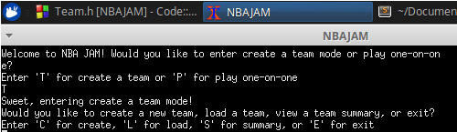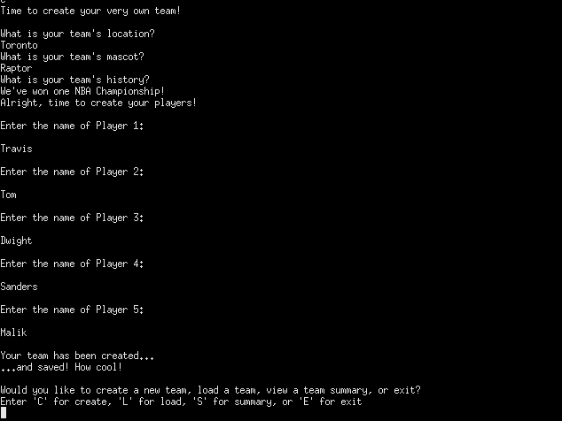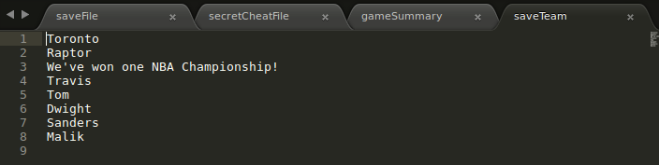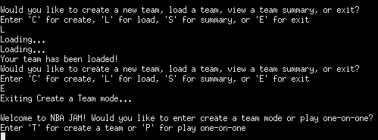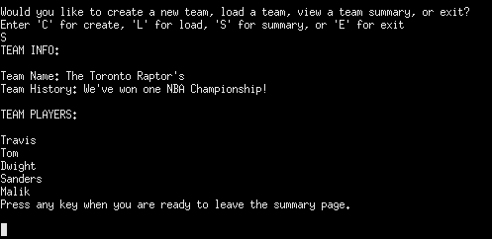

**Start Screen → Create a Team**

**Team creation – A team name, mascot, history, and 5 Players.**

**Teams are saved after being created – this means they can be loaded even after exiting.**

**If the user wants to view their team, they can Using the Summary Option!**

Create A Player Mode

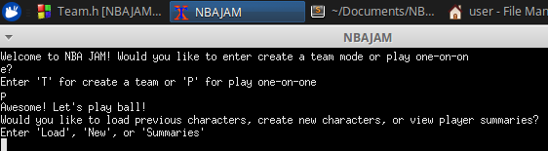 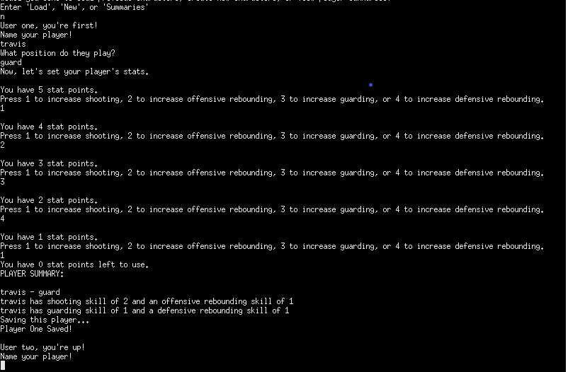

**Note that the player is saved upon creation.**

**With a name, position, and stats!**

**Here, they can create a player**…

**Alternatively, players can access ‘Play One-on-One’ mode.**

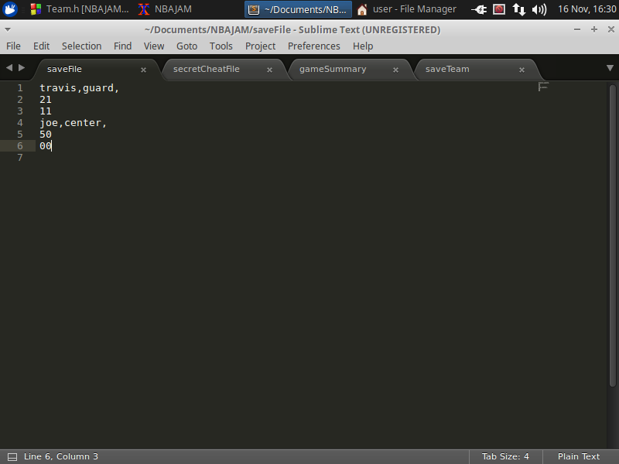 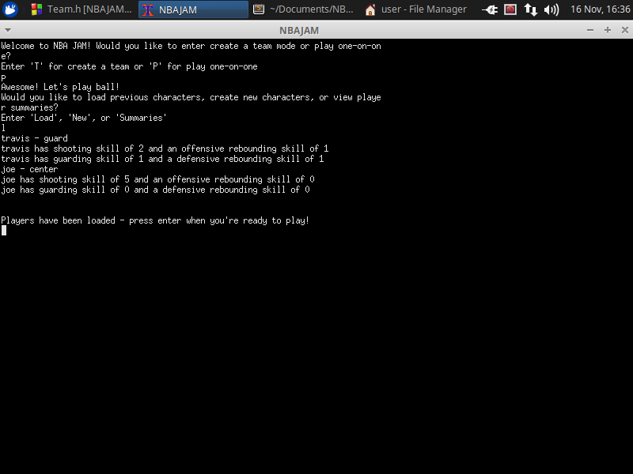

**And can be loaded for use in any future game!**

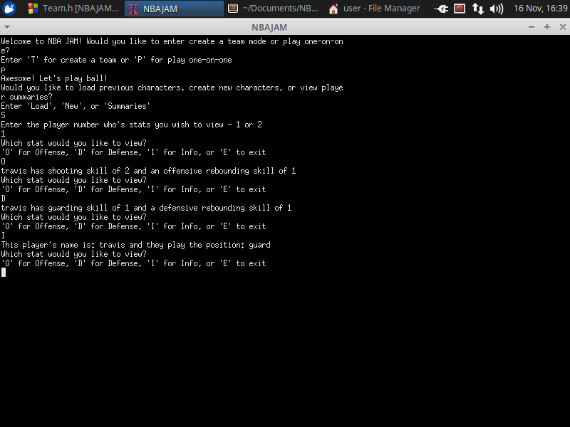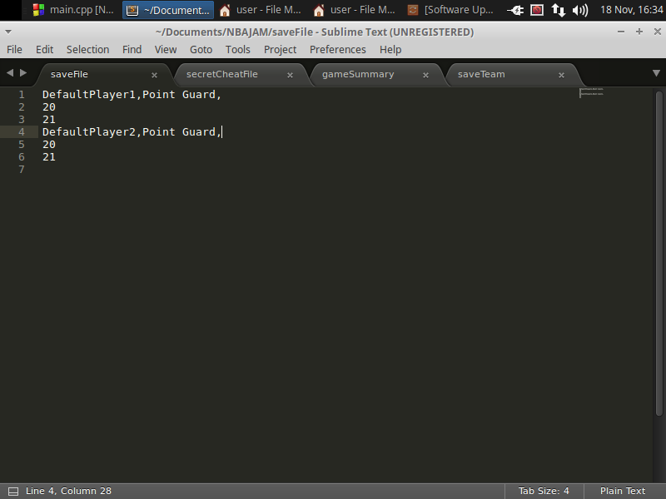

**A player’s info and stats can always be viewed as well!**

**Should the user choose not to Create Players, They can use default players**

Play One-On-One Mode:

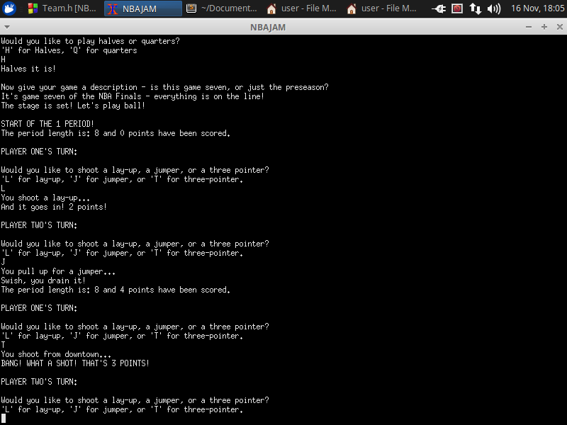

**Once players are loaded, the user decides the game length and gives the game a description.**



**To play, the users switch off, each deciding whether they want to shoot a lay-up, jump shot, or three.**

**Note: Each period is a randomized number of points.**

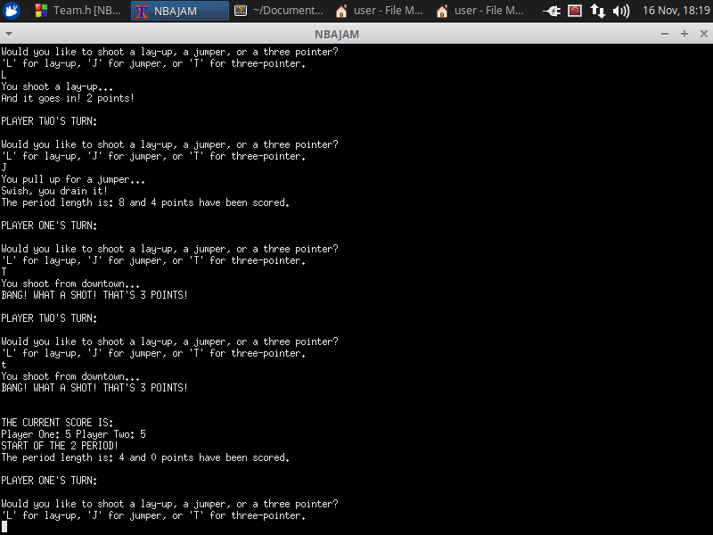

**And a new, random period length is set.**

**End of the period! The users are shown the score…**

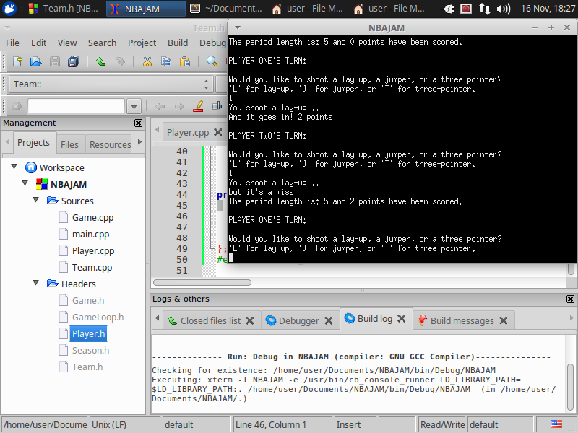

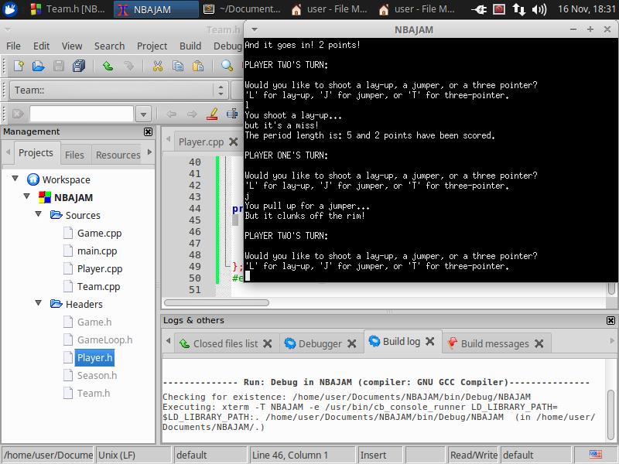

**Missed shots have different output text**

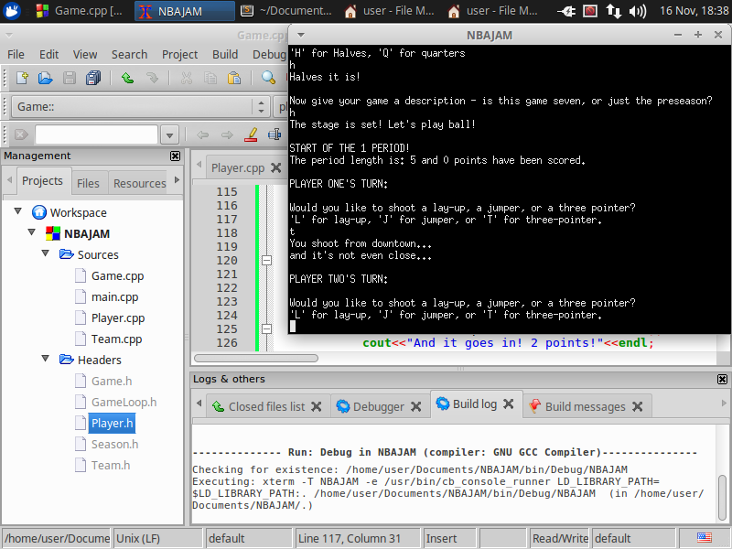

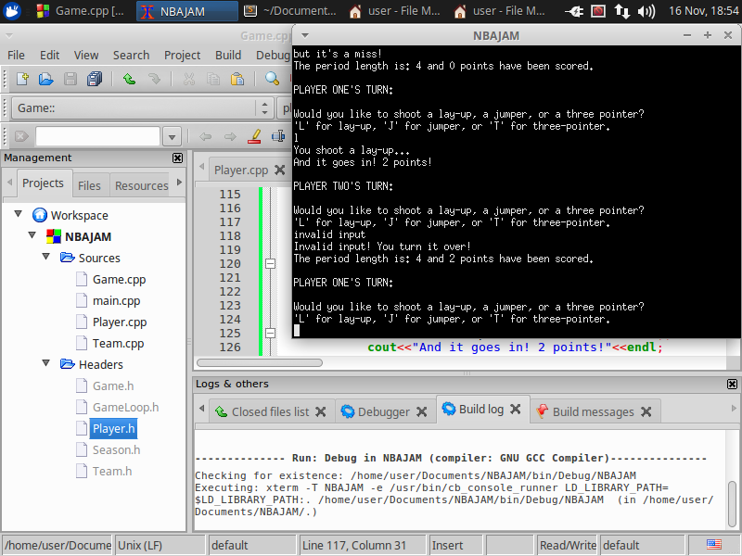

**Or maybe you turn it over!**

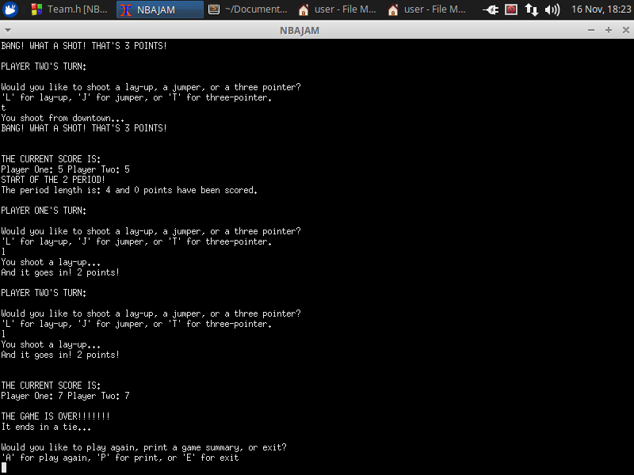

**Once the game is over, the score is displayed and a game summary can be printed!**

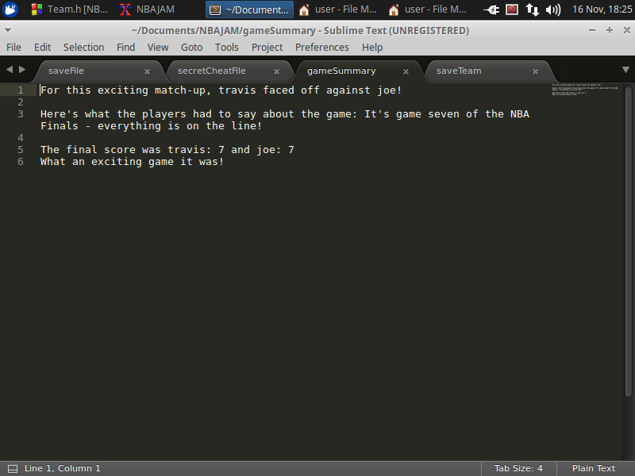

**The user also has the option to play again or exit.**

Secret Cheat Codes

Keep this on the down-low, but in case you’re ever struggling to beat your friend at our game, use our cheat codes!

**In the file ‘secretCheatFile’, write ‘makeshot’**

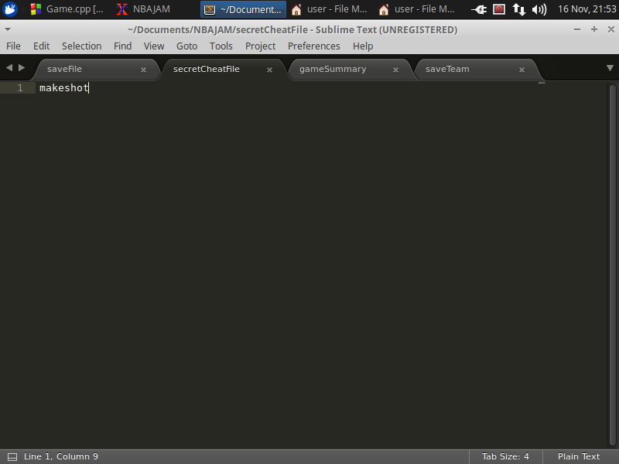

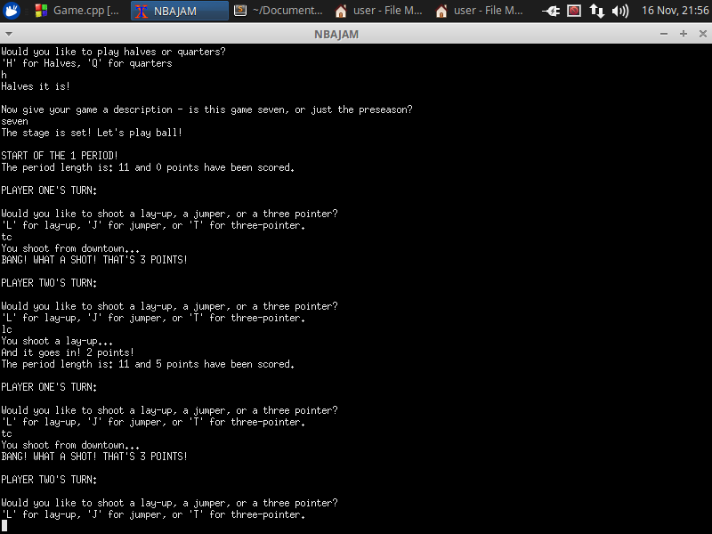

**Put a ‘C’ after your shot selection and the shot will always go in!**

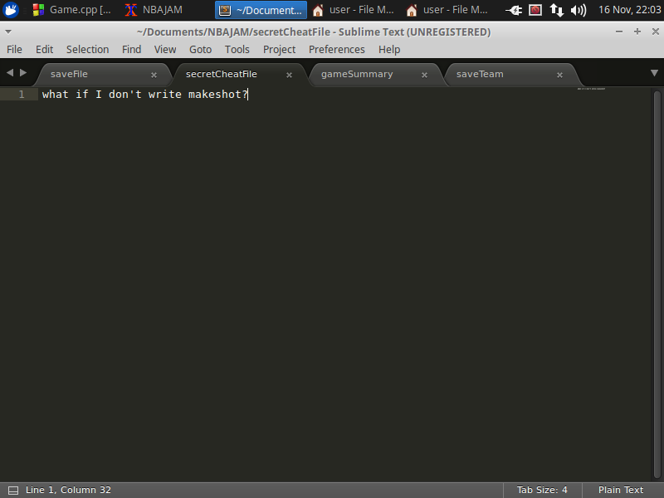

**Careful though! If the file doesn’t contain ONLY ‘makeshot’, the cheat won’t work!**

